Ex. No: 10
Date: 01/05/2026
Introduction to Antivirus
Experiment No. | 10
Experiment Title | Introduction to Antivirus
Platform | TryHackMe
Hours Required | 2
TryHackMe Link | https://tryhackme.com/room/introtoav

AIM
To understand how antivirus (AV) software works, explore its detection techniques including static and dynamic analysis, learn how to test AV software using tools like ClamAV and YARA rules, and understand AV fingerprinting methods used during penetration testing.
Antivirus (AV) software is one of the essential host-based security solutions available to detect and prevent malware attacks within the end-user's machine. AV software consists of different modules, features, and detection techniques. As a red teamer or pentester, it is essential to be familiar with and understand how AV software and its detection techniques work. Once this knowledge is acquired, it will be easier to work toward AV evasion techniques.

TOPICS COVERED
- Task 1: Introduction
- Task 2: Antivirus Software
- Task 3: Antivirus Features
- Task 4: Deploy the VM
- Task 5: AV Static Detection
- Task 6: Other Detection Techniques
- Task 7: AV Testing and Fingerprinting
- Task 8: Conclusion

THEORY
Introduction to Antivirus
Antivirus (AV) software is an extra layer of security that aims to detect and prevent the execution and spread of malicious files in a target operating system. It is a host-based security solution installed on a machine to monitor and detect suspicious activities.
Traditional Antivirus solutions such as Kaspersky, AVG, Norton, Malwarebytes, and Windows Defender serve the fundamental cause of securing the machine. Antivirus comes as a package consisting of scanners, engines, a signature database, and a sandbox environment. Each component has its own purpose in the detection process.
Antivirus Software
AV software is considered a host-based security solution because it is installed and runs directly on the end-user's machine. The first AV software on the market was implemented by McAfee. It works by scanning files against a database of known malware signatures.
Key AV components:
- Scanner: Scans files, directories, and processes for malicious activity
- Detection Engine: Core engine that performs signature matching and behavioral checks
- Signature Database: Contains MD5/SHA hashes and patterns of known malware
- Sandbox Environment: Isolated environment to safely execute and analyze suspicious files
- Unpacker: Restores or decrypts compressed executables to their original form for analysis

Antivirus Features
Modern AV software includes multiple advanced features to detect and mitigate threats:
- Emulator: Analyzes malware in a safe and isolated virtual environment without risk to the host
- Unpacker: Decompresses or decrypts packed executables back to their original form
- Heuristic Analysis: Detects previously unknown malware based on behavioral patterns
- Real-time Protection: Continuously monitors the system for suspicious activity
- Firewall & Network Inspection: Examines network traffic for malicious patterns
- Self-protection Driver: Guards the AV itself against being attacked or disabled by malware
- Management Console: GUI or CLI interface for managing scans, quarantine, and reports

AV Static Detection
Static detection is the simplest and most basic form of AV detection. It analyzes files without executing them. There are three main approaches to static detection:
- Signature-based Detection: Compares file hashes (MD5, SHA1, SHA256) against a known malware database
- String/Pattern Matching: Searches for known malicious strings or byte patterns within files
- YARA Rules: Uses custom rules to identify malware based on specific patterns, strings, or metadata
ClamAV is an open-source antivirus engine used in this room for static detection exercises. It supports signature databases in .hdb format and custom YARA rules.

TASK BREAKDOWN
TASK 1: Introduction
No answer needed. This task provides an overview of the room and its learning objectives, including an understanding of AV software, detection methods, and how to test and fingerprint AV software from a red team perspective.

TASK 2: Antivirus Software
Q1: What does AV stand for?
Ans: Antivirus
Q2: Which PC Antivirus vendor implemented the first AV software on the market?
Ans: McAfee
Q3: Antivirus software is a ___-based security solution.
Ans: Host

TASK 3: Antivirus Features
Q1: Which AV feature analyzes malware in a safe and isolated environment?
Ans: Emulator
Q2: An _______ feature is a process of restoring or decrypting the compressed executable files to the original.
Ans: Unpackers
Q3: Read the above to proceed to the next task, where we discuss the AV detection techniques.
Ans: No answer needed

TASK 4: Deploy the VM
A Windows 10 Pro machine is provided for this room. The VM can be accessed through the in-browser feature. Once the VM is deployed, the browser splits into two windows. Alternatively, you can connect via RDP using the credentials below:
- Machine IP: MACHINE_IP
- Username: thm
- Password: TryHackM3
Q1: Once you've deployed the VM, it will take a few minutes to boot up. Then, progress to the next task!
Ans: No answer needed

TASK 5: AV Static Detection
In this task, we use ClamAV to perform static detection on sample binaries. Three test files are provided on the desktop: EICAR test file, Backdoor 1, Backdoor 2, and AV-Check. We use sigtool to generate MD5 signatures and the strings tool to extract human-readable content.
Q1: What is the sigtool tool output to generate an MD5 of the AV-Check.exe binary?
We run the following command in the terminal:
"c:\Program Files\ClamAV\sigtool.exe" --md5 AV-Check.exe
The output of the sigtool command is shown below:
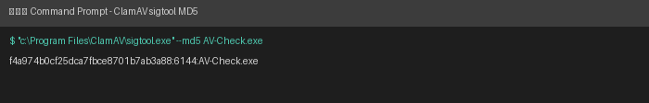
Ans: f4a974b0cf25dca7fbce8701b7ab3a88:6144:AV-Check.exe
Q2: Use the strings tool to list all human-readable strings of the AV-Check binary. What is the flag?
We run the strings command to extract readable text from the binary:
strings AV-Check.exe
The output reveals human-readable strings inside the binary, including the debug path and the hidden flag:
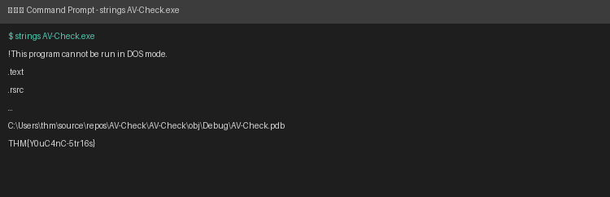
Ans: THM{Y0uC4nC-5tr16s}

TASK 6: Other Detection Techniques
Beyond static analysis, modern antivirus solutions use additional detection methods:
- Dynamic Detection: Analyzes malware behavior during execution inside a sandbox or virtual machine
- Heuristic Detection: Uses rules and algorithms to identify suspicious behavior patterns
- Cloud-based Detection: Leverages cloud databases for real-time threat intelligence updates
- Behavioral Detection: Monitors system calls, memory access, and file modifications at runtime
ClamAV is also used here to test dynamic behavior of the provided backdoor samples.
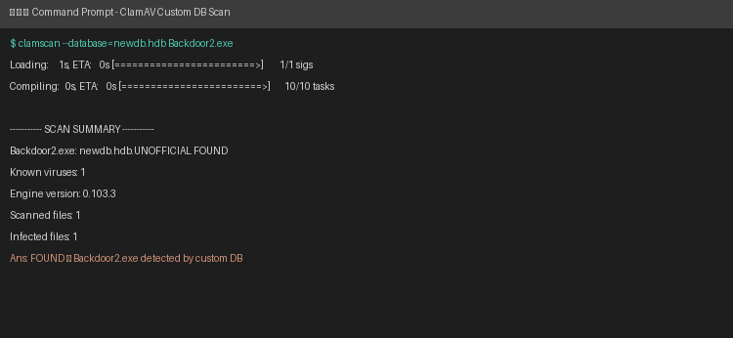
Q1: Which detection method is used to analyze malicious software inside virtual environments?
Ans: Dynamic Detection

TASK 7: AV Testing and Fingerprinting
AV fingerprinting is an essential process to determine which AV vendor is present on a target machine. Once initial access is gained, identifying installed security software helps red teamers plan appropriate evasion techniques.
Common AV fingerprinting methods include:
- Service Names: Checking running services (e.g., WinDefend for Windows Defender)
- Process Names: Listing active processes to identify AV agent processes
- Registry Keys: Examining known AV registry paths under HKLM\SOFTWARE
- Filesystem Paths: Checking for AV installation directories under Program Files
- Domain Names: Checking network connections to known AV update server domains
In PowerShell, the following command can be used to check Windows Defender status:
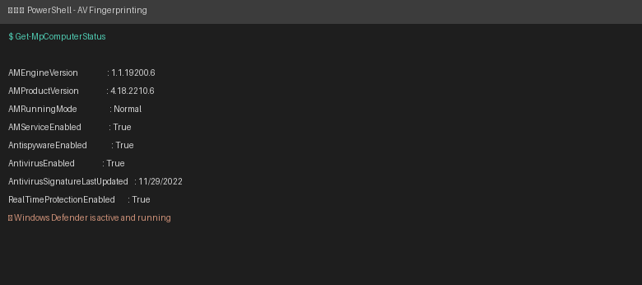
The output confirms that Windows Defender is active and running with real-time protection enabled.
Q1: For the C# AV fingerprint, try to rewrite the code in a different language, such as Python, and check whether VirusTotal flags it as malicious.
Ans: No answer needed (hands-on exercise)
Q2: Read the Above!
Ans: No answer needed

TASK 8: Conclusion
No answers needed. This task concludes the room with a summary of what was covered.

RESULT
Successfully explored antivirus software fundamentals including AV architecture, detection approaches (static, dynamic, heuristic, and behavioral), and performed hands-on exercises using ClamAV to detect malware through MD5 signature matching, custom .hdb databases, and YARA rules. Also completed AV fingerprinting exercises to identify installed security software on a target system using service names, process listings, registry keys, and PowerShell cmdlets. This knowledge forms the foundation for understanding AV evasion techniques used in red team engagements.

